CENWP-OD-TDD 12/3/20

MEMORANDUM FOR THE RECORD 20TDA13 East Fishladder dewater lamprey mortalities

SUBJECT: Lamprey mortalities, The Dalles East fishladder

The Dalles East fishladder was dewatered on Dec 2,2020. Numerous Salmonids, Shad and several Sturgeon were guided to tailwater or removed by bag and released to tailwater. No lamprey were observed during the entire dewatering procedure by any of the staff. Flushing water was reduced for a final inspection to ensure all small fish were found in shallow areas between weirs. The following day 3 lamprey were found dead atop grating. It is assumed they came from under the grating during the night.

- Species – Pacific Lamprey
- Origin – unknown
- Length – unknown
- Marks and tags – unknown
- Marks and Injuries found on carcass – none visible
- Cause and Time of Death – stranding atop grating, overnight 2 December.
- Future and Preventative Measures – Flushing water can remain on overnight, but this can create unwanted attraction to fish from tailwater and further potential stranding. And it will still leave exposed grating due to ladder slope. Regular access to this area is constrained by time and logistics. We continue to investigate preventative options.

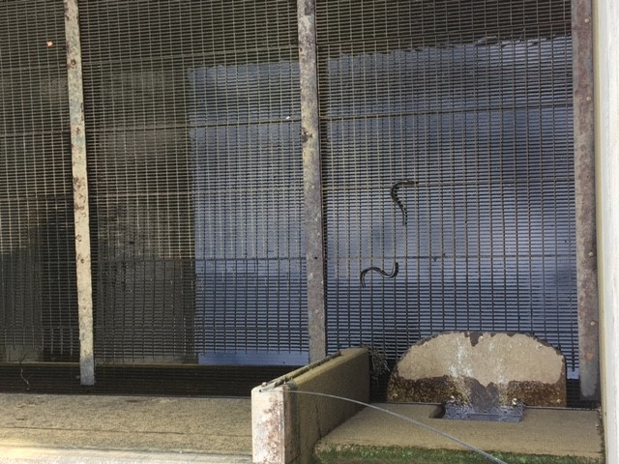
Sincerely,
Bob Cordie
Project Fisheries

